Quiz

Lecture 1: Lecture Title

- Explain how the lecture seeks to explain the idea of Periphery?

- What is the most critical understanding of the periphery and overlapping peripheries that is communicated in the lecture?
- That the periphery and overlapping peripheries are fixed lines
- That the periphery and overlapping peripheries are cultural zones of interaction and exchange
- That the periphery and overlapping peripheries are impossible to resolve
- That the periphery and overlapping peripheries are no longer relevant

- Within the overlapping questions suggested as a take away following the 9 lectures, which is the most radical departure from conventional architectural history courses:

- That history hardly matters
- The study of history is impossible for architects
- We can potentially move to a broad understanding of history, one that is beyond the physical artifacts themselves
- History needs more picture books

- In terms of chronological time and place, what kind of research methodology is suggested by the lecture?

- We must study complete history
- We must skip time periods of little relevance to us
- Specific and culturally-significant space-time moments are of great value to see the intersections of history
- Only local histories must be examined

- Besides the Slavic, Persianate and the Indian realms, Nomadic Eurasia and the Silk Road were discussed as exemplars of 'peripheral' history. However, this last-mentioned region was viewed differently - it was identified as:
- Historically insignificant
- A mix of cultures
- A lawless geographical land
- A Spatial interregnum or Cultural Matrix

6. Within the context of the Indian Subcontinent, what phenomena does this diagram illustrate?

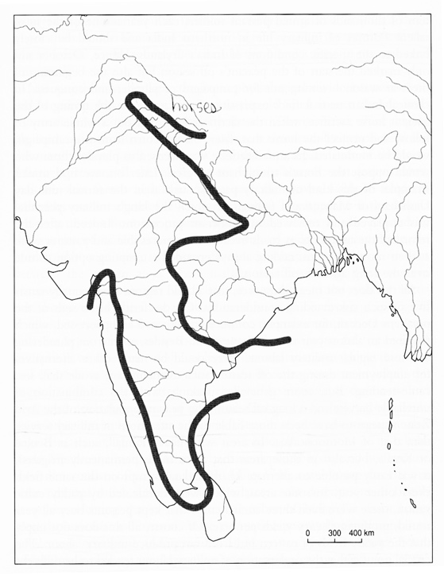

7. The following diagram illustrates the arrival of …… into the Persian plateau, which created ……

- Muslim Arab Army, new centers in the heartland of Persia
- Timurid army, new centers in the north east and western frontiers of Persia
- Turkish groups, new centers in the eastern and western frontiers of Persia
- Timurid army, new centers in the heartland of Persia

8. Within the context of the Slavic World, what incursion of outsiders into Slavic lands do the two illustrations provided discuss. Who were the outsiders shown in each? And where did they establish the new cultural centers?

- Muslim Arabs in Moscow
- Italian Priests in Suzdal, attempting to establish a new pilgrimage center
- Guests from overseas (painted by Nicholas Roerich, 1901) and the Siege of Kiev by the Mongols in 1240 CE.
- French scientists in Latvia

